ENSE 374

Milestone 4: Lo-Fi Prototype, and Documentation

Software Group B

Members: Avery, Nic, Renz, Jiahao, Jinkai, Mackenzie

**Table of Contents:**

List of Images: 3

Overview: 4

Homepage: 5

Programs: 6

Faculty and Research: 9

Forms: 11

Info: 13

**List of Images:**

Image 1: Homepage 5

Image 2: Navigation Bar 5

Image 3: Programs Overview 6

Image 4: Courses Overview 6

Image 5: Courses Specific 7

Image 6: Committee Overview 7

Image 7: Committee Specific 8

Image 8: Faculty Overview 9

Image 9: Research Overview 9

Image 10: Forms Overview 11

Image 11: Faculty Forms Example 12

Image 12: Info Overview 13

Image 13: Info Contact 14

**Overview:**

The overall Lo-fi design was to provide rough sketches of work, intended setup and appearance of the website. The sketches provided in the document are examples of the result of the lo-fi design process, pages with similar setup and navigation were omitted such as form categories, faculty categories and categories under info. This is to reduce the duplication of design and keep lo-fi design simple for similar pages. Content is represented with squiggles in text boxes or in some cases example text, this is to provide context to potential information that will be included.

Navigation throughout the site is meant to be intuitive and quick, the use of search bars is meant to reduce searching time and drop downs provide quick navigation to certain pages. As well, frequently used processes will include useful links to most used content to help consistent needs be met easier.

Security within the site will be handled with a login to the Cascade Server which will associate various security groups, such as, admin, with the user. As well, content that will be protected by these groups will be analyzed using a ‘Who’, ‘What’, ‘Why’ approach to make sure content is not allowed to unintended users.

Usability questions are also listed to help assess the success of the website at achieving the goals of intuitiveness and easy to navigate.

**Homepage:**

The content will be dynamic in order to provide links to the most useful content at a specific time in the semester, as seen in Image 1 below. For example, the content could provide a link to the course registration content of the website during the early days of a semester and or provide a link to the graduation content of the website in the middle or at the end of the semester after courses cannot be dropped. It will also contain the frequently used processes or tasks which could possibly be the page directory of all the staff members due to the fact that the staff members has to work interdependently to give access to certain information.

*Image 1: Homepage*

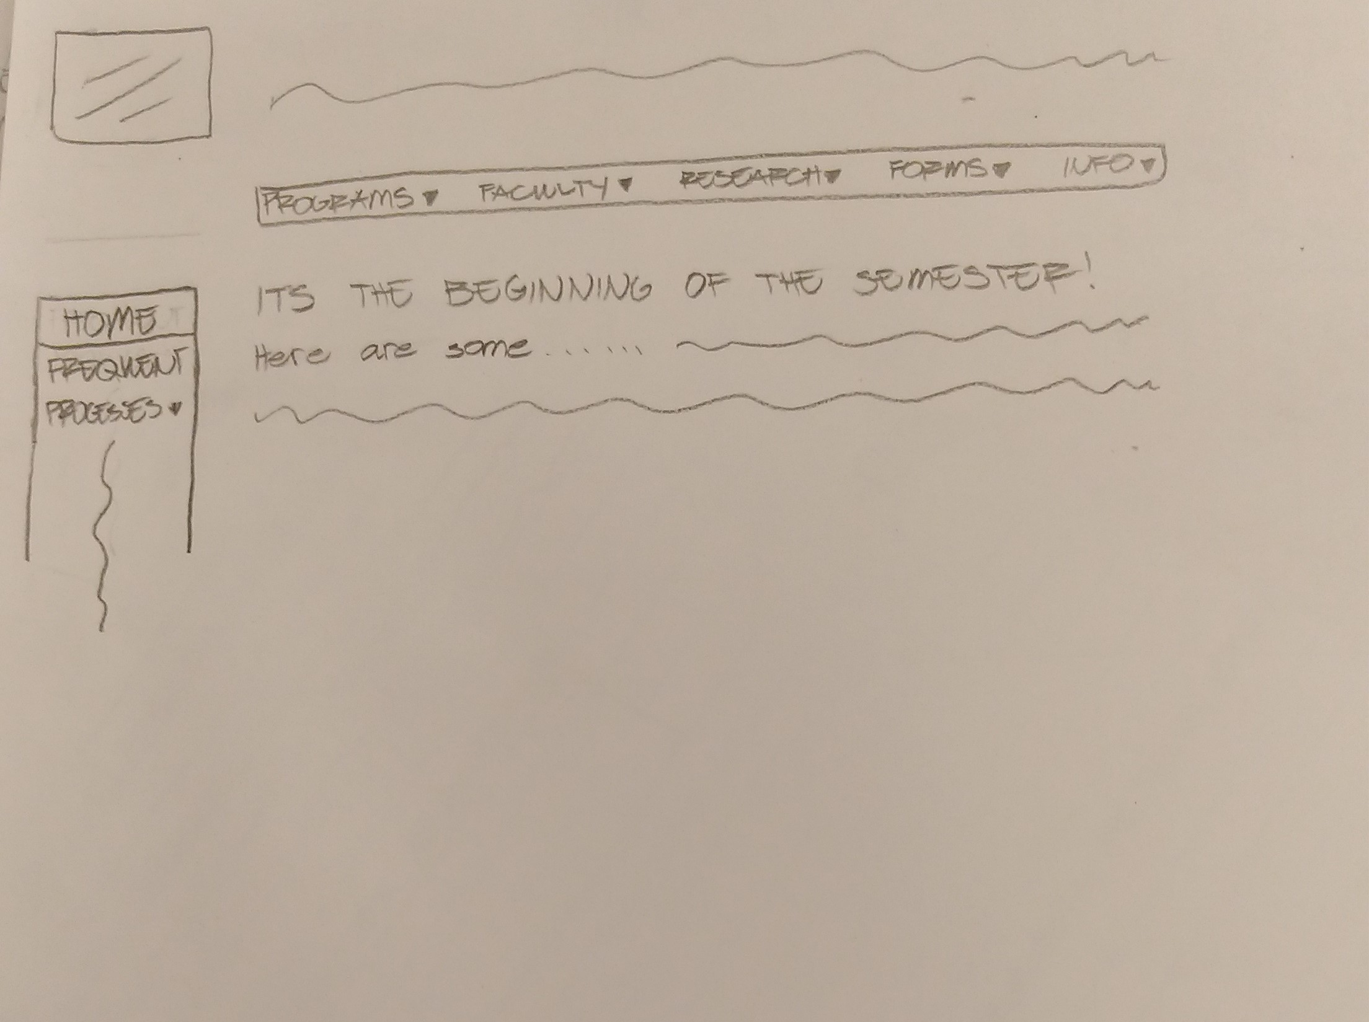

Regarding the homepage, the basic structure of all the other pages will be similar to this page. They will all have the University of Regina logo as a header along with the title “Faculty of Engineering”. All the pages will also have a main navigation bar as well as a smaller listed version of the page’s content in a side navigation bar. Furthermore, the workflow within the pages will also be similar. The main access to pages and or links will be through a dropdown hierarchy list as seen in Image 2.

*Image 2: Navigation Bar*

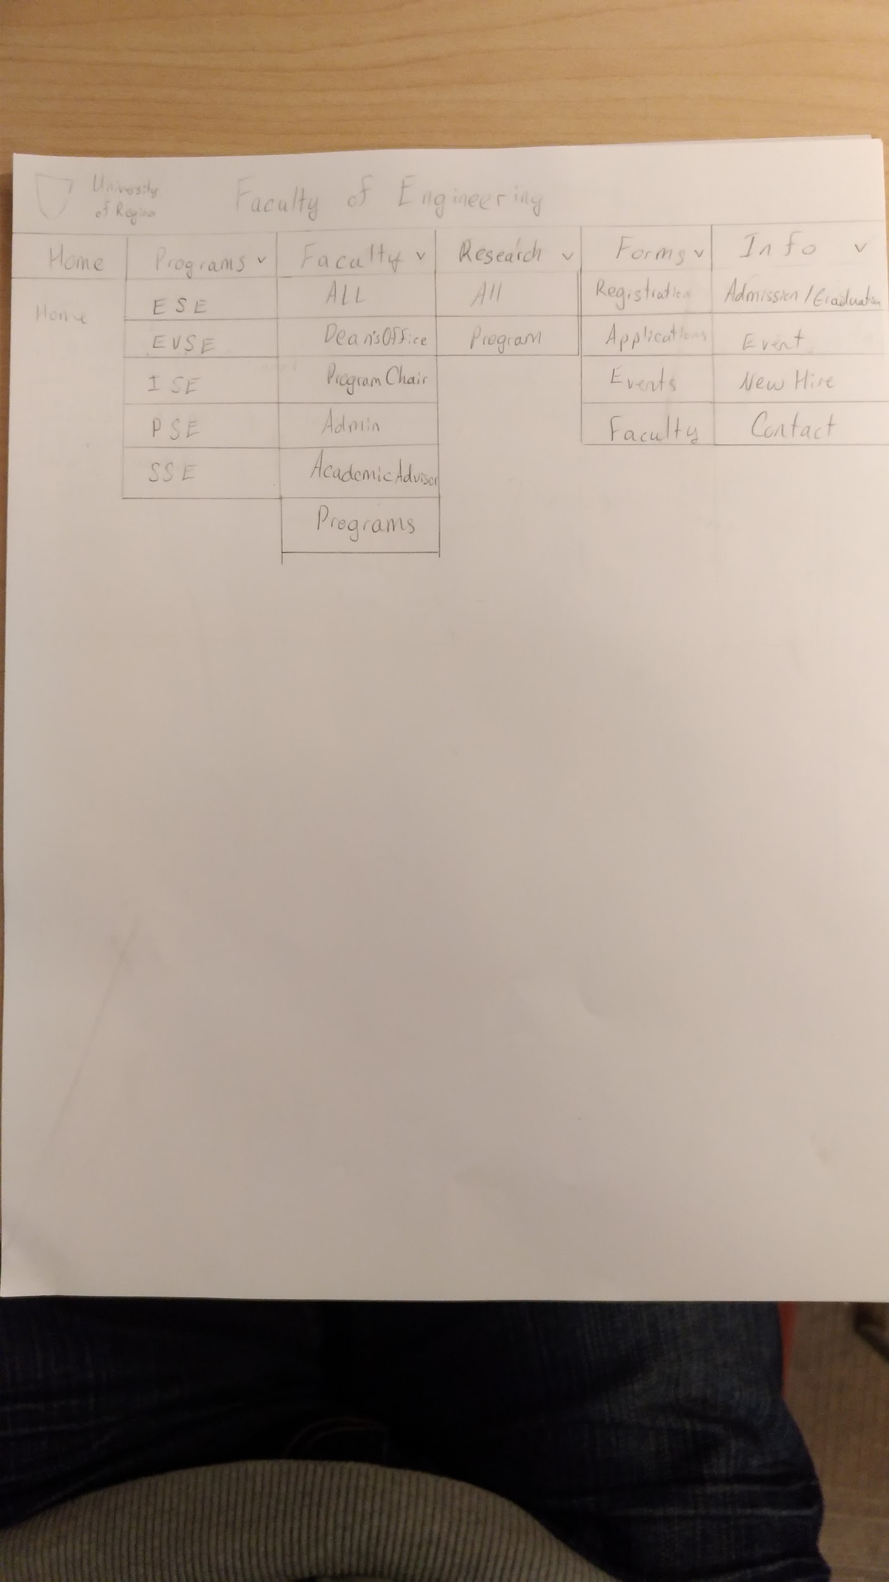

Usability Evaluation:

How would you rate navigation using the drop down menus?

**Programs:**

The content of the program page will mainly focus on the courses and committees offered by the faculty of engineering in the University of Regina with links to associated forms and faculty as pictured in Image 3. The courses and committees will be separated by the selected programs and restricted based on access defined in user groups.

*Image 3: Program Overview*

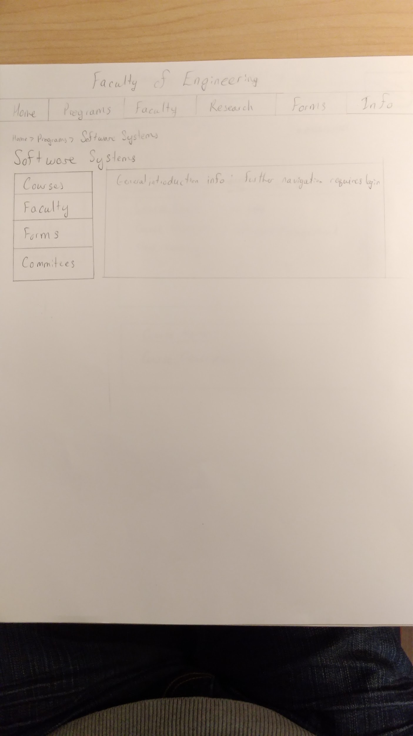

Courses will contain a search by course level, such as 100, or 200 level, as seen in Image 4 below. Included in the list of courses will be a short description for easier searching. As well, when a course is selected, past resources such as professor, lecture notes, assignments and exams will be available. This will be sorted by year, with each individual semester in the year listed as seen below in Image 5.

*Image 4: Courses Overview*

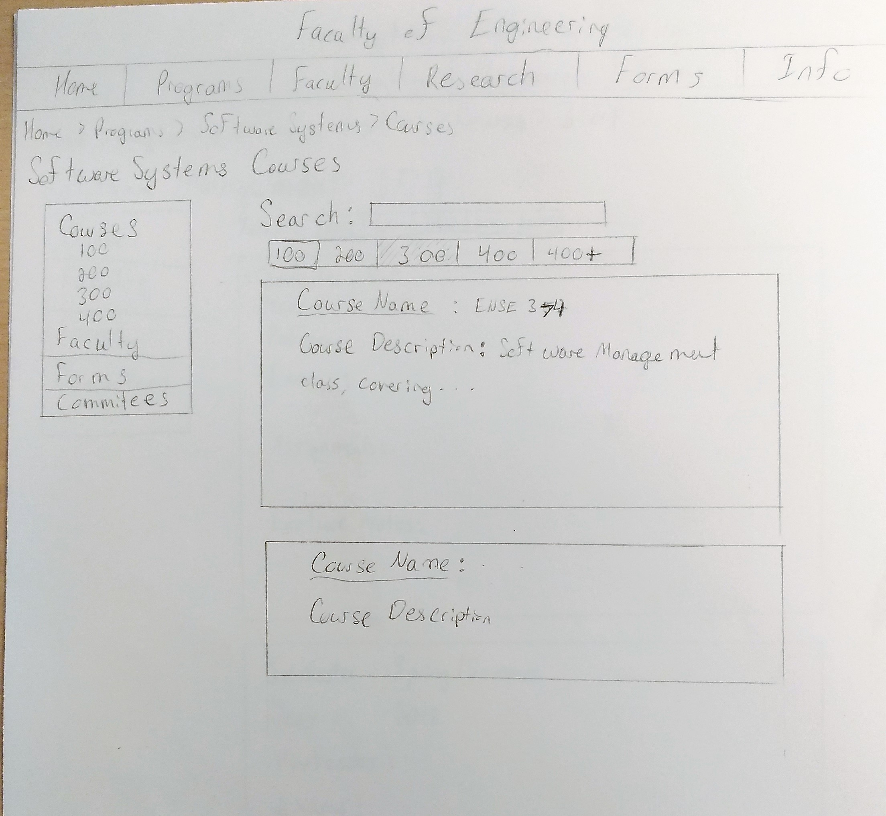

*Image 5: Courses Specific***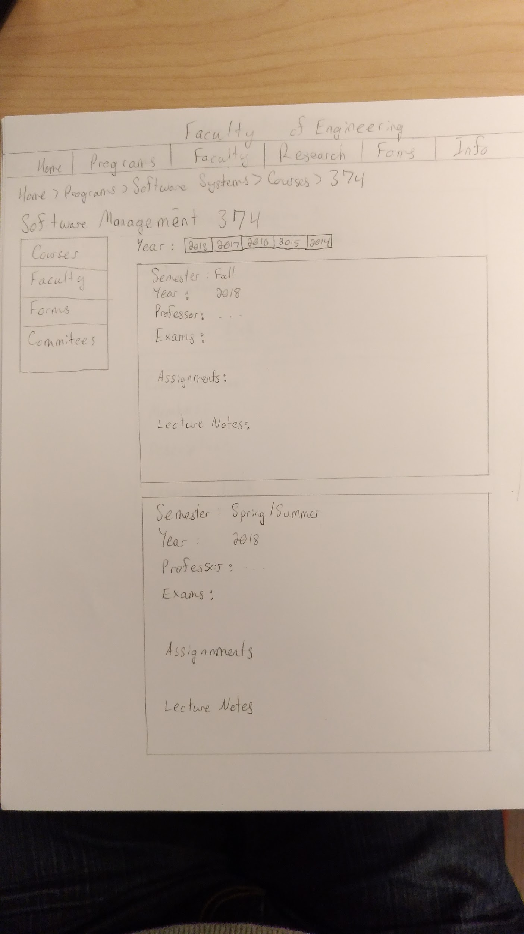**

Committees will contain a list of committees associated with the faculty seen in Image 6 below. Similar to courses, committees will be listed by year with information on members and meeting minutes from the committee, shown in Image 7. This will require the user to be part of the committee if there are concerns about privacy.

*Image 6: Committee Overview*

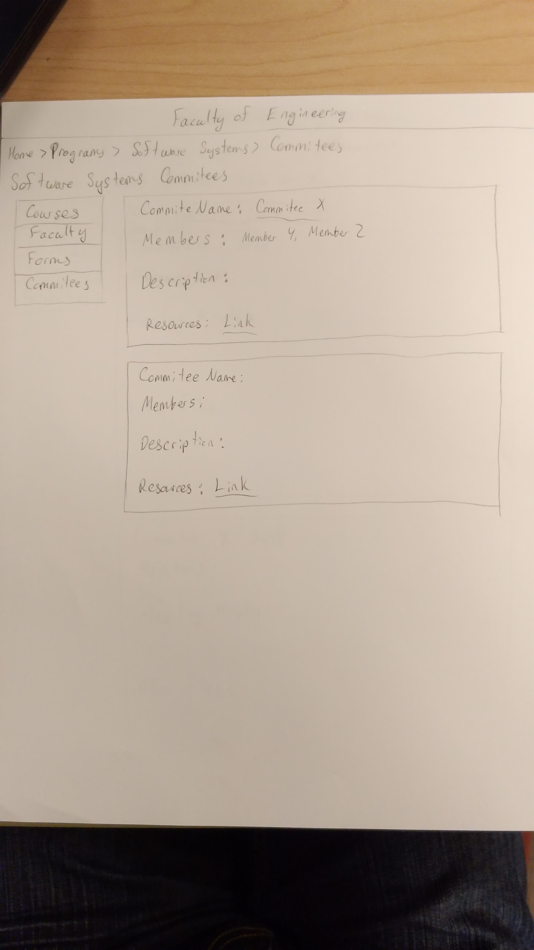

*Image 7: Committee Specific*

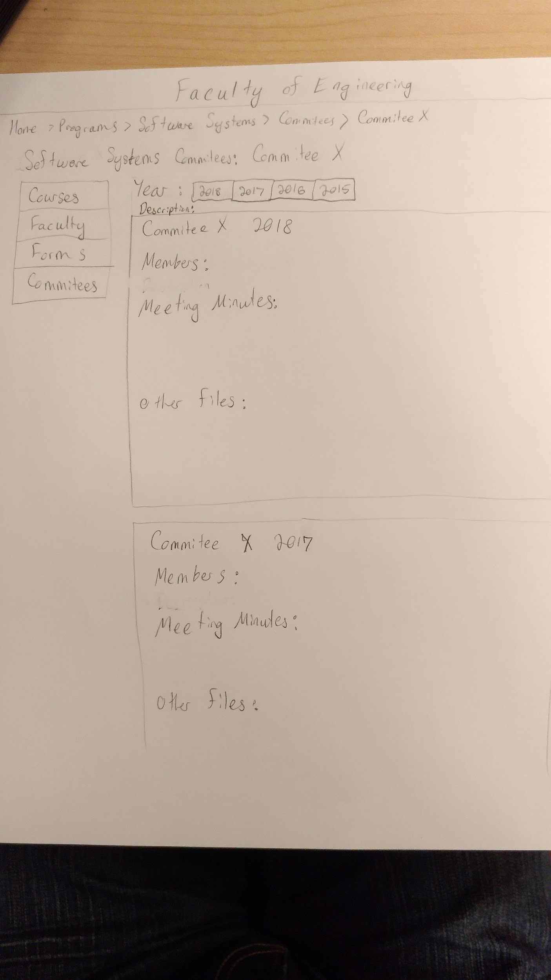

Navigation:

Navigation through the programs pages will use a sidebar for second and third level navigation as needed. The items in courses and committees will be searchable using the top bar which contains links to sort content as seen in the images below.

Security:

Security for programs will be separated by program and committees the user is a part of, this will be associated through login with the use of user and faculty groups.

Usability Questions:

Find the following course [ENSE 374]

Find meeting notes from the following committee, [Committee X]

How was navigating to [page]?

How did navigation compare to what you expected?

These questions will allow the assessment of navigation and allow for suggestions to be considered and the process to be improved to fit the user’s needs.

**Faculty and Research:**

**Faculty:**

The main content of the faculty page is the information of each faculty/staff members. Information such as their photograph, research interests and contact information. In terms of navigation, the page itself will initially list all of the faculty and staff members in alphabetical order by their first name. The page; however, will allow users to modify and ease their experience by having a function to search a specific faculty member by the first letter of their last name. Moreover, there will also be a search bar that will suggest matching staff members by the given keyword from the user.

*Image 8: Faculty Overview*

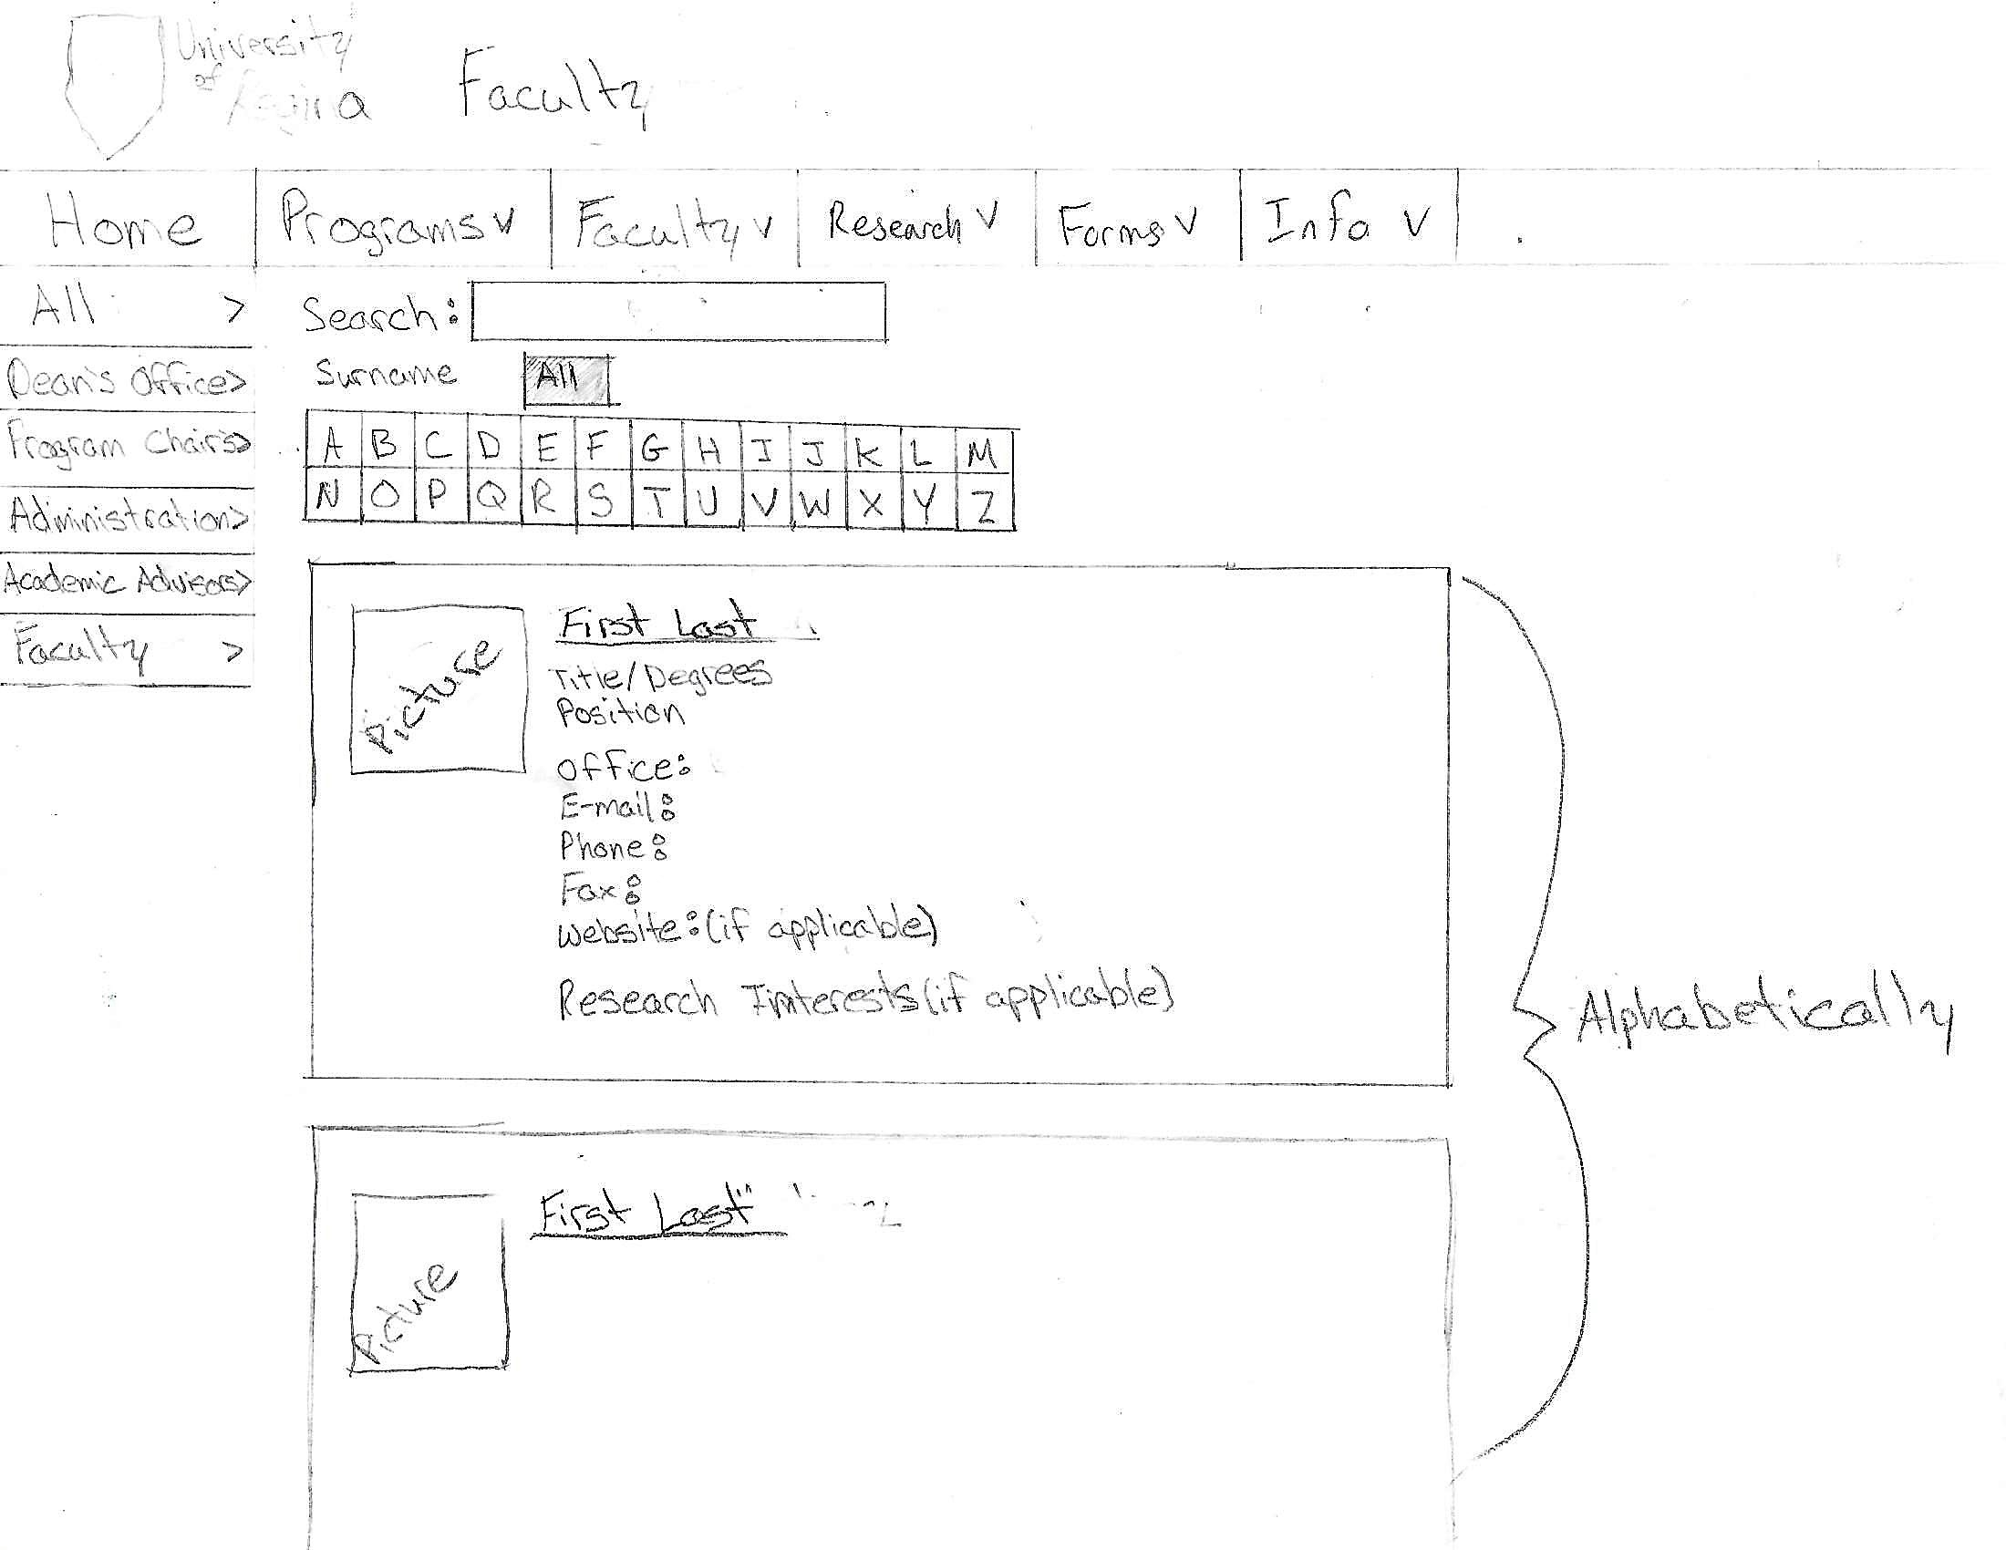

**Research:**

The content will mainly focus on the different programs with links to the faculty page of members with specific research interest in the associated field.

*Image 9: Research Overview*

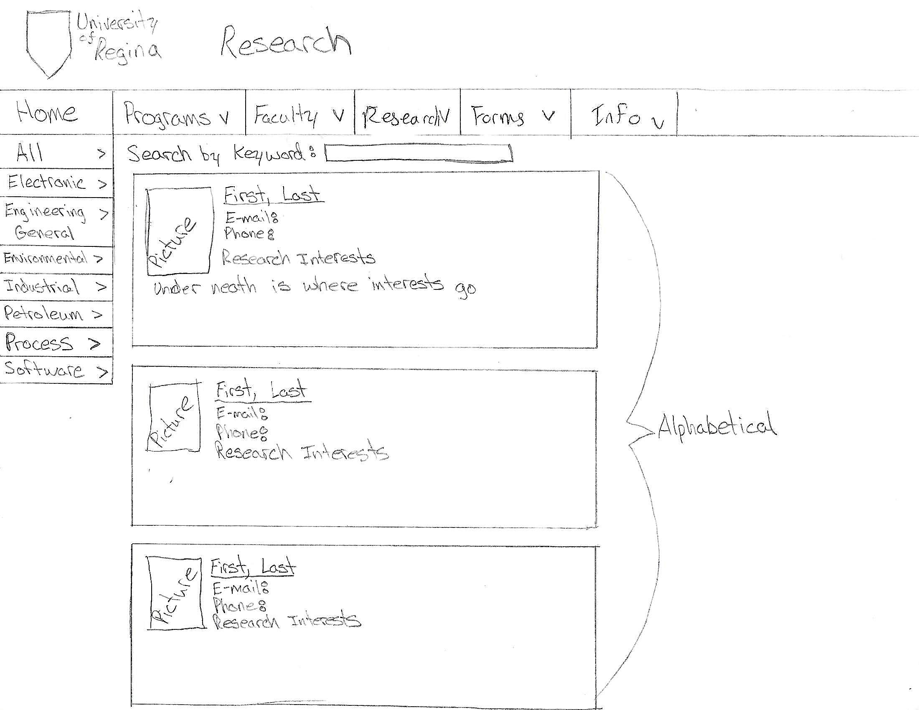

Usability Evaluation:

Through our Lo-fi sketches, we came to the conclusion that research and faculty could potentially be combined. This would be a user question to ensure that we are doing what is best for the user as we are not the user ourselves and it may be beneficial to have these separated.

* Would navigation benefit from having Faculty and Research combined under one heading?

**Forms:**

The forms page will contain all the forms categorized by registration, application, events, faculty, and others. These categories will initially be displayed in a grid-based structure with links to its associated forms. A side navigation bar will also exist as a hierarchical model of the main content of the page. The forms will also be searchable similar to courses, committees and faculty staying with the consistency planned as part of our content.

Usability Evaluation:

1. How easy was it to find specific forms? Forms are currently a point for improvement, if navigation is easier than the current model then the structure is helpful, if not we need to dig deeper and determine what helps the user most.
2. Did contents and the navigation look simple and clear?

Clear intuitive navigation of forms is ideal, this question can help deepen our understanding of what the user likes and dislikes about navigation.

*Image 10: Forms Overview***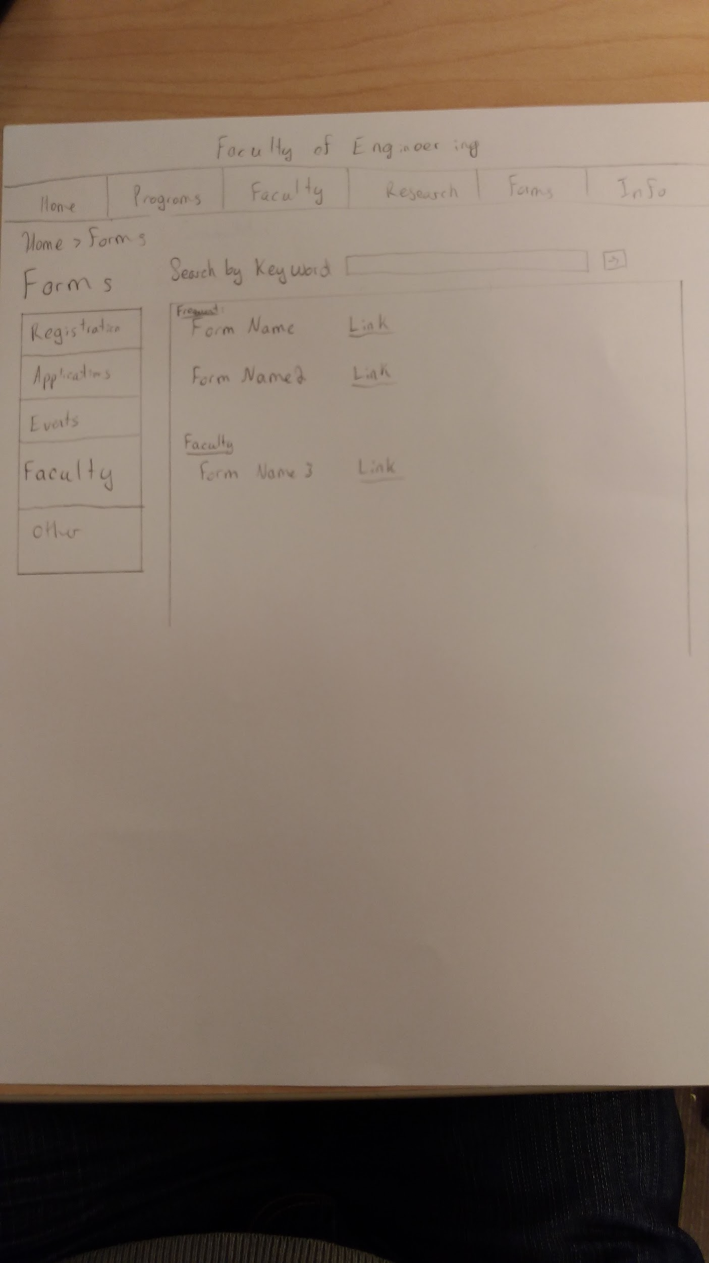**

*Image 11: Faculty Forms Example***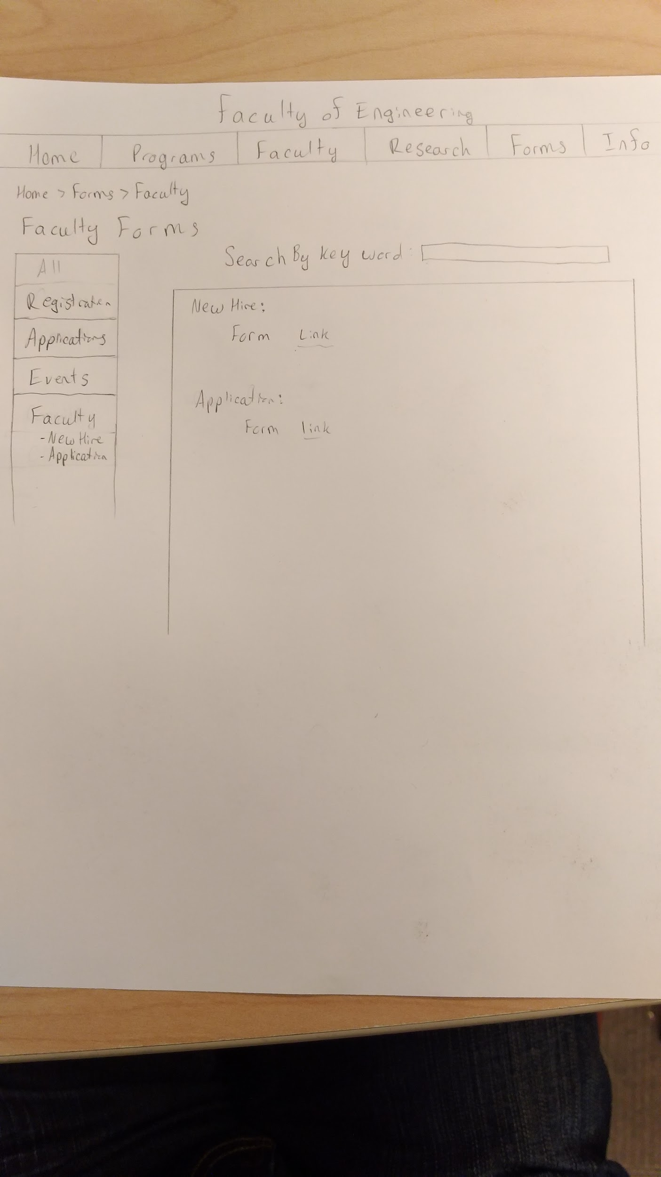**

**Info:**

Overall the Info page is composed of Admission/Graduation, New Hire, Contact, Safety Policies, FAQs and Events. The information shown on the main page is only the partial. Navigation bar will lead the user to a more detailed page, such as new hire for each department. Calendar is used in Events section, it will lead the user to view specific detailed dates. Some primary information also will be shown sequencely in this section, a hyperlink something like “view more” can be added below. FAQs will be answering basic inquiries for user, for example, IT support center and academic Q/A for each faculty.

*Image 12: Info*

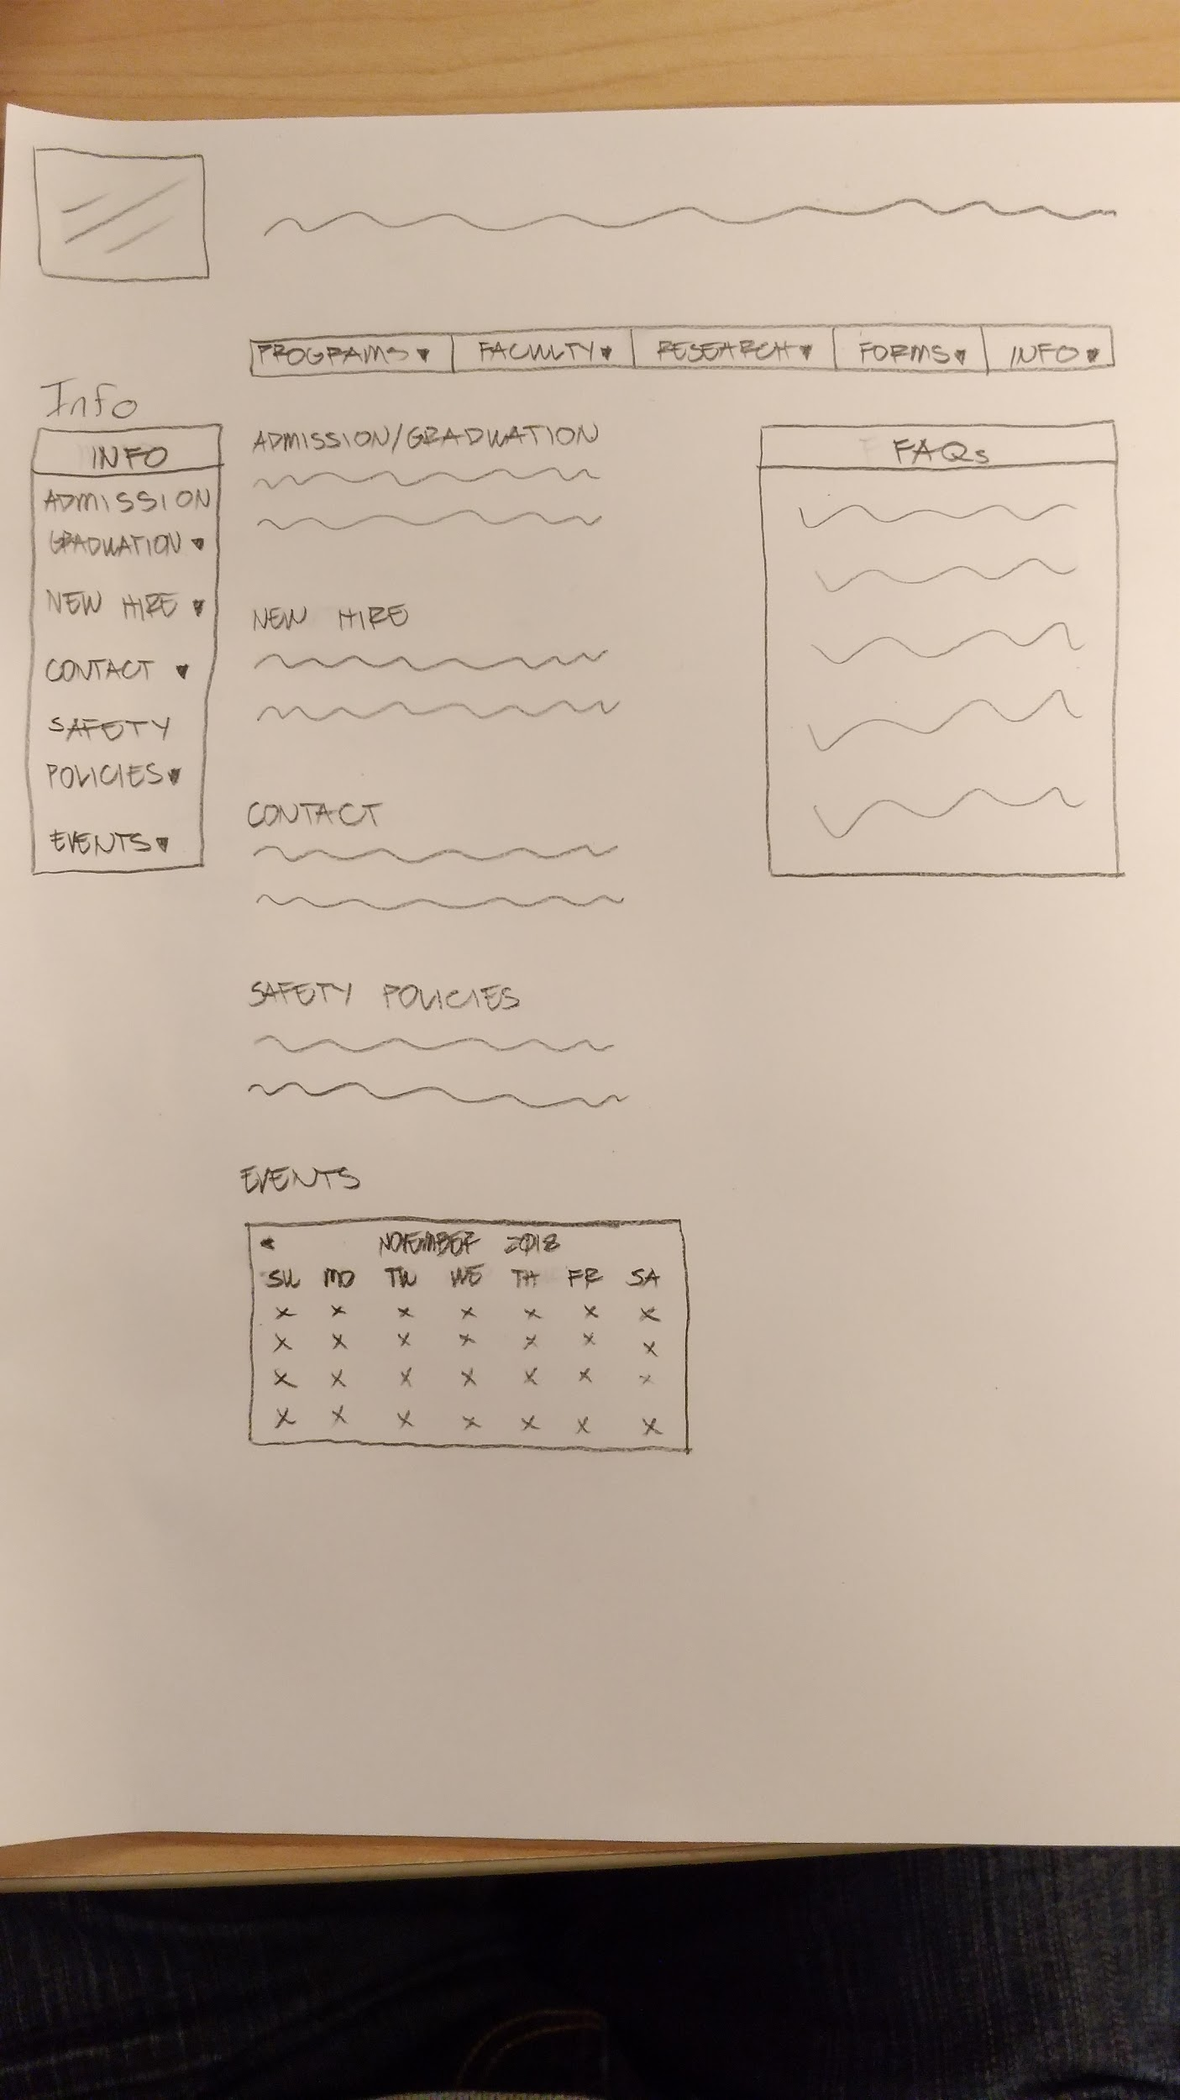

*Image 13: Contact*

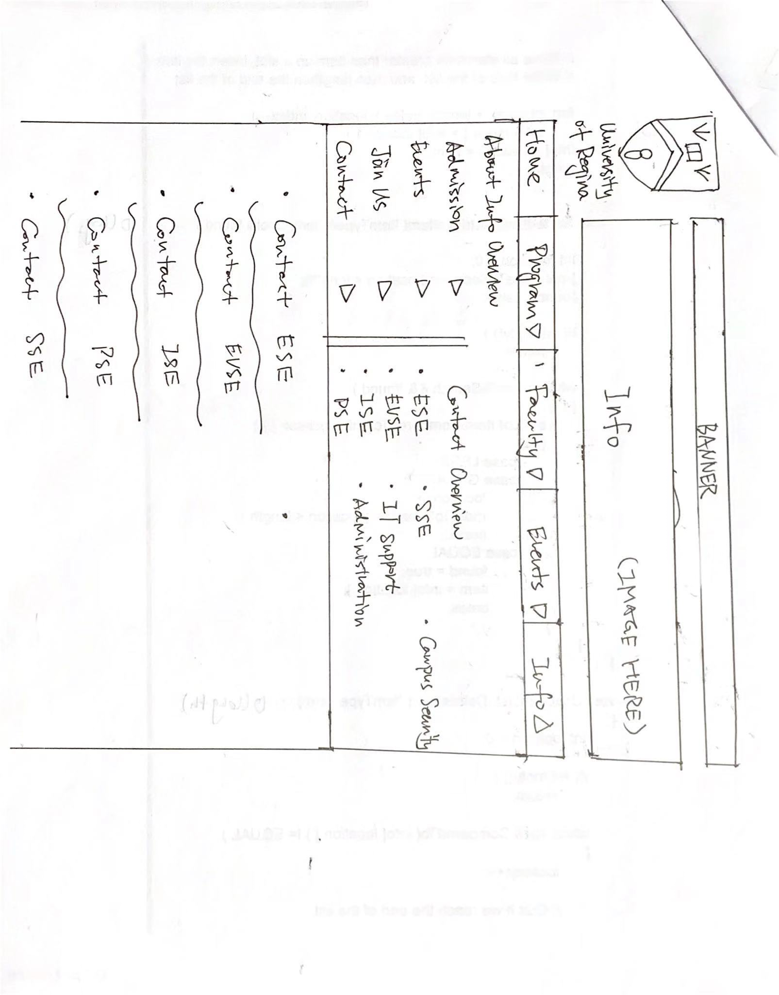

Usability Evaluation:

Did you have difficulties to find the events in event section?

The events tab is meant to be a general calendar for the faculty, if it proves useful this may be moved to the homepage for easier navigation and viewing if users suggest changes.

Does the info provide meaningful content?

Since the info page is more general information, content may need to be changed or reorganized in order to make it meaningful to the user and helpful to them. Suggestions from the current faculty site will be taken to improve the efficacy of the information.